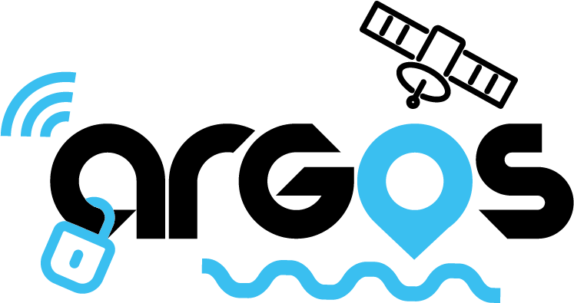

ARGOS – Questionnaire for vessel manufacturers

- Introduction
ARGOS stands for Anti-theft Robust Galileo-based Operational System and our aim is to implement the new Galileo features and develop an innovative board/device for vehicle tracking. The main drivers are the design and development of a product with the following cutting-edge features:
- Scalable and modular in architecture, performance, functionalities and interfaces.
- Adaptable to different types of operations and users from yachts to bikes, from trucks to earth moving vehicles.
- High robustness against environmental conditions and external factors
- Easily upgradeable and maintainable.
- Use of Galileo OS Navigation Message Authentication (OSNMA) and I/NAV Message Improvement capabilities to improve robustness and availability.
- Use of the Machine Learning based algorithm to improve robustness and performance of the localisation function.
- Use of patented encryption method based on OSNMA keys to increase the security of the communications between the ARGOS elements.
The use of ARGOS, that can be considered as a sort of “Blackbox”, continuously acquiring and storing the vessel position, will give evidence of the performed navigation route and will bring 3 additional benefits:
- The use of Galileo, in addition to GPS, will improve the availability of the position information.
- The use of the Galileo OSNMA and the anti-tampering function of the ARGOS Board will increase the robustness against spoofing or manipulations.
- The Machine Learning based algorithm of ARGOS will provide dead reckoning capabilities and increased positioning performance.
The ARGOS Solution is answering to user needs and requirements, collected from the users that have been contacted. The leisure vessels are subject to potential theft attempts.

Two situations are considered: vessel anchored in a natural harbour and vessel anchored in a pier.
For the two situations, the following protections shall be foreseen:
- The Vessel shall be protected both from the potential movement outside the Mooring at Anchor Radius – MAR (potential risk of both theft attempt or anchor sliding) and from the potential movement outside a Safe Distance (SD) determined by the distance from rocks or dangerous elements.
- The Vessel shall be protected against theft attempts determined by movements outside a Safe Distance (SD).
Based on these conditions, the ARGOS core algorithm, driven by Artificial Intelligence technology, implemented in the ARGOS Device will elaborate the data coming from the GNSS Receiver and other sensors in order to provide the position information with the higher accuracy and availability. The position information, elaborated in time with innovative Dynamic GeoFencing techniques in the Control Centre together with the alarm conditions defined by the user, will determine the triggering of Risk Alerts to be sent to the User.

More info about our project here: https://www.argos-project.eu/

Contact details of the person filling-in the questionnaire:
Your name
Your company
Your function
Email address
Telephone number

II. Questions & Answers
1. Please select the type of vessels you are currently manufacturing:
a) Leisure vessels b) Commercial vessels
c) Others (please add information):
__________________________________________________________________
2. What is the number of vessels produced / year by your company?
___________________
3. Which countries does your distribution channels covers?

4. Are you interested in integrating innovative technology into your products to make them more appealing to your customers?
__________________________________________________________________
5. Are you currently integrating technology from third-party into your own products, and if yes, which technology?
- YES
please provide more info:
________________________________________________________________
b) NO
6. Do you currently have a satellite communication integrated into your products?
- YES b) NO

7. Do you see the integration of innovative technology into your own products as an advantage in your selling process, in the relation with the client?
- YES b) NO

8. Does your product currently include vessel monitoring systems as a standard or optional feature for your clients?
- YES b) NO

9. Would you be interested in integrating our ARGOS product into your own products?
- YES b) NO

10. Which rules, regulations, laws, trade agreements need to be considered for our product to be eligible to be sold by your company together with your own products?
__________________________________________________________________

11. Are you willing to participate in a pilot project to test our product with your vessels and send us the results and customer feedback?
- YES b) NO

12. Which specific features would you like us to include into ARGOS?

___________________________________________________________________
- Additional information

- Can we contact you for other information and clarifications?
Yes No

- Do you have any document, report, paper that you may suggest or share with us in support of ARGOS business/ economic analyses?

________________________________________________________________________

Thank you for your kind collaboration and for the time devoted in filling-in this questionnaire!

